Steven Reveles

Braulio Duran

Isabella Linarez

Alex Bernatowicz

## Campus Connect Project Proposal

### **Interactive Experience Introduction**

Campus Connect is designed to help university students overcome the common problem of feeling disconnected from their peers due to mismatched schedules. This web app will integrate with the university calendar system, campus events, and personal calendars. Providing a seamless way for students to view each other’s availability and plan social or study meetups. By improving the coordination of plans among friends, the project aims to foster a more connected and engaged campus community where students can make time for brief or extended hangouts, strengthening social and academic networks. This significant project focuses on user experience and information design tailored to university students. Users can quickly see their friends' schedules and available time slots, which will be visually represented with clear availability indicators. This simplicity and real-time campus event integration allow for spontaneous or planned meetings, making social coordination hassle-free. By avoiding overly complex server-side functionality, the app can use APIs like Google Calendar to pull in relevant calendar data. Ensuring the functionality is well within the team’s development skill set. The prototype will be evaluated with a small group of students on campus, and feedback will drive iterative improvements. The intended users are university students who want to arrange social or study meetups with their peers. Usability is central to the design objectives, keeping the interface intuitive and responsive. This lets users quickly find free time slots among friends and set up events. The app’s novelty lies in its campus-centric integration and ease of use, helping students stay socially and academically engaged despite busy or conflicting schedules. This project is worth pursuing because it addresses a real problem of social disconnect. It can potentially enhance student life with minimal overhead, focusing on data privacy and providing a meaningful, user-centered experience.

### 

### 

### 

### **Sketches & Diagrams**

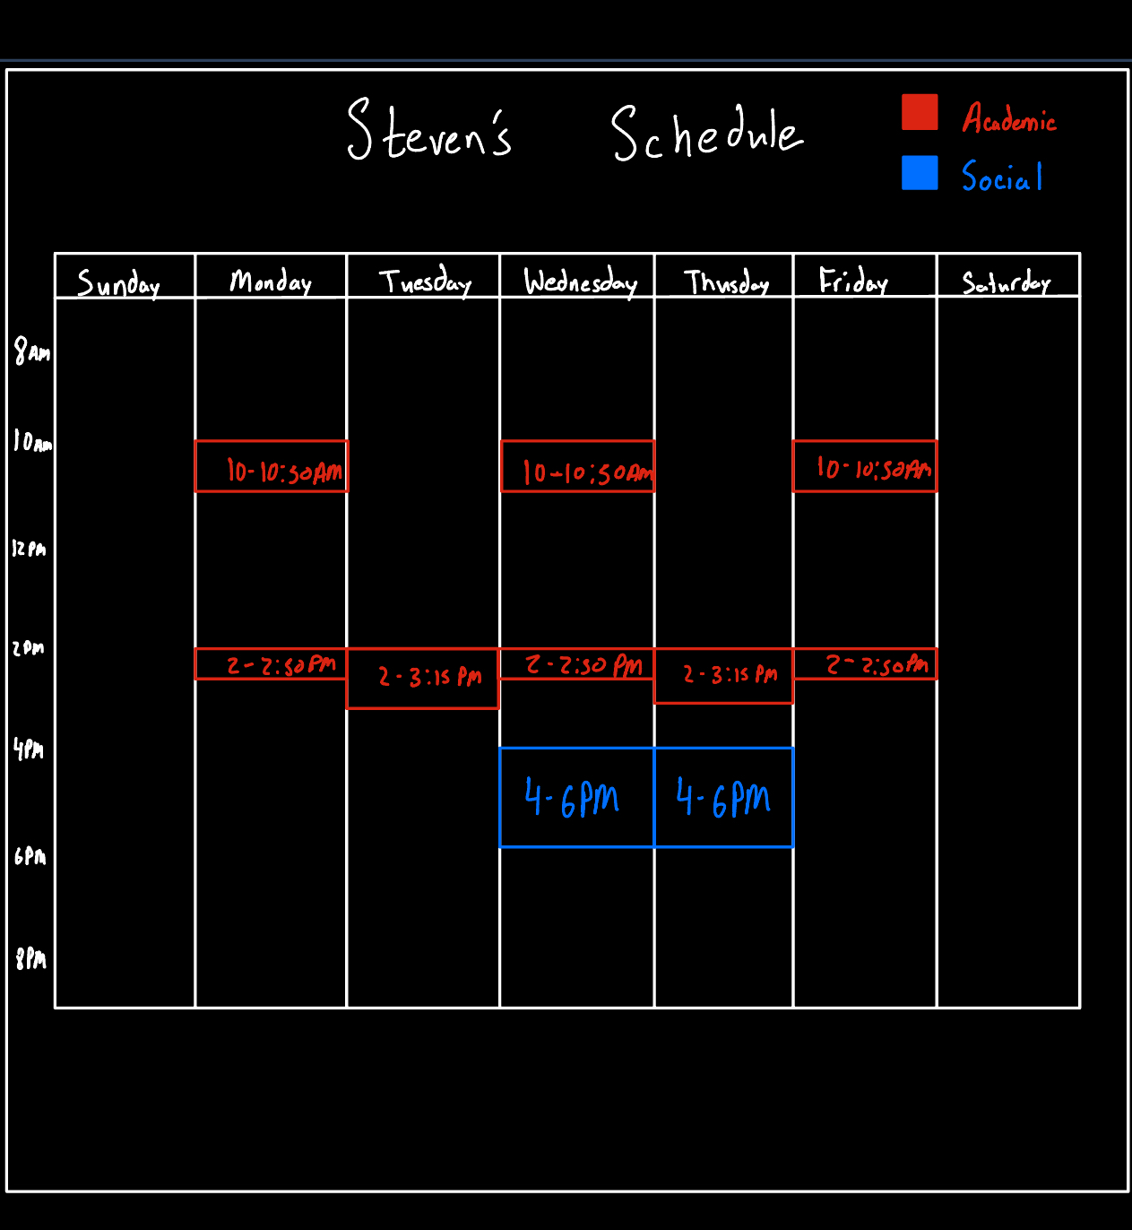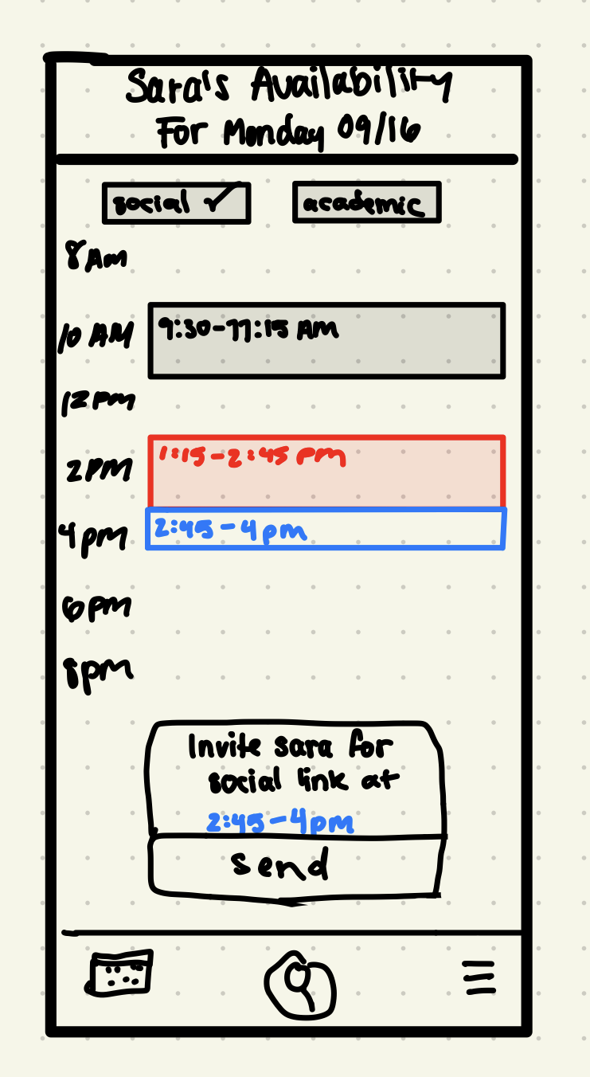

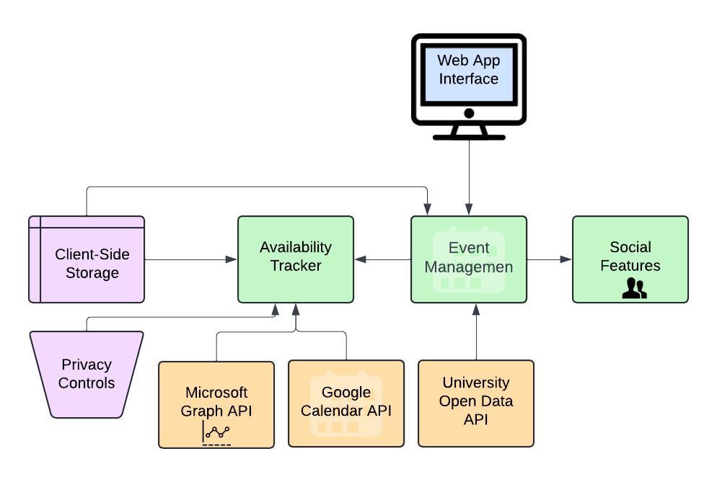

### **Users and Needs**

Our app is designed for coordination purposes by the university students at UIC. On campus, there is an apparent disconnect as students find it hard to see their peers due to conflicting schedules, especially because it is a commuter school. According to the National College Health Assessment (American College Health Association, 2019), over 60% of college students “felt very lonely in the past year” for 2019. This is even more concerning, given that the pandemic happened only after, contributing to the deterioration of the mental health of students. To combat this, we aim to help students by designing a platform that will sync their class schedule and club events, which will be shareable to the friends of their choice on campus. This will eliminate the back and forth of coordinating through text where the plans usually fall through. Campus Connect intends to streamline making plans to hangouts or to study, which boosts their social interaction and overall college experience. To gather participants, we'll reach out to classmates, friends, and members of student organizations. Being part of the UIC community makes it practical to connect with peers for feedback. A study found that students' academic success and happiness are correlated with feeling connected to others (Durlak et al., 2011). For the Requirements study, we will interview the students and ask them about the challenges they encounter when trying to meet with someone on campus. For the Low Fidelity Prototype, we will show them the basic design of the platform to get feedback and further develop. For the Functional Prototype, we'll build a basic version of the app that shows the main features, even if it's not fully developed, and ask students to test it themselves.

### **Precedents**

Several existing applications offer calendar and scheduling functionalities, but none specifically address the needs of university students in a university campus environment.

1. **Google Calendar:** A widely used tool for personal scheduling. However, it lacks social features tailored for university students to connect, and campus events are not directly available on the calendar.

2. **Doodle:** Allows users to find a suitable meeting time by polling participants. While useful, it is more suited for one-time events and lacks updates on real-time availability.

3. **Facebook Events:** Provides users the ability to create events and send invitations to others, although it does not provide a visual representation of others' availability, nor does it integrate various calendars

Campus Connect distinguishes itself by:

**Campus-Centric Integration:** Direct integration with university schedules and campus events.

**Real-Time Mutual Availability:** Visualizing friends' availability in real-time through calendar integrations.

**Privacy Controls Specific to University Context:** Tailored privacy settings that consider the unique social dynamics of a campus.

### **Ingredients:**

To build Campus Connect, we will utilize the following technologies:

**Google Calendar API:** To access and integrate users' personal calendar data, allowing real-time availability updates.

**HTML5 Local Storage:** To store user preferences and data on the client side, avoiding the need for complex server-side storage and enhancing privacy.

**Front-End Frameworks:** Utilizing React.js for building a responsive and dynamic user interface.

### **Innovation:**

Campus Connect offers a unique solution that combines personal scheduling with social coordination in a university context. Unlike generic calendar apps, it focuses on:

**Mutual Availability Visualization:** Providing a clear, color-coded calendar that displays the user's schedule and the overlapping free times with friends.

**Campus Integration:** Incorporating university events and schedules directly into the app, making it a one-stop platform for all campus-related activities.

**Privacy Tailored to Students:** Implementing privacy controls that reflect the social nuances of university life, allowing users to decide who can see their availability.

**Value to Users:** By addressing the specific challenges university students face in coordinating social interactions, Campus Connect enhances campus life, promotes social well-being, and supports academic collaboration

### **Project Plan:**

#### Scope: We will develop a functional web application for Campus Connect that focuses on schedule management, viewing friends' availability, and sending invitations which will effectively demonstrate our concept within the project's time constraints.

#### Components to be Designed and Developed

**1. Front-End (UI/UX)**

* *Calendar View Interface*: A calendar interface that shows the user’s schedule alongside friends' availability using color-coded slots.
  + Develop a user-friendly calendar where users can view/manage schedules.
  + Allow users to import their schedules using the Google Calendar API.
  + Use color-coding to indicate free and busy time slots.
* *Event Creation Interface*: Simple screens for creating events or meetups
  + Allow users to select a free time slot and send an invite to a friend for a meetup.
  + Invitations will be sent within the app and send out calendar invitation.
* *Friend Availability View*: Shows specific availability of specific friend
  + Enable users to see the schedules of their friends who have shared their calendars.
  + Display overlapping free time slots to identify possible meetup times.
  + Simulate this by pre-loading friends' schedules with their permission.
* *Privacy Settings Interface*: A dashboard that allows users to control who sees their availability (public, private, friends-only)
  + Provide basic options for users to control who can see their availability (e.g., share with all, share with specific friends).
  + Implemented conceptually without complex backend support.

**2. Back-End (API Integration / Data Management)**

* *HTML5 Local Storage Integration:* Client-Side Data Handling
  + Store user preferences and schedules on the client side.
  + Avoids the need for server-side databases and enhances privacy.
  + Data persists across sessions on the same device.
* *Calendar API Integration*: Using Google Calendar API to pull personal calendar data and display mutual availability between friends.
  + Implement the Google Calendar API to allow users to import their schedules.
  + Since we won't develop authentication measures for the prototype, we'll manually input schedules for students we know (with their permission) to simulate API integration.

#### Team Responsibilities

**Alex Bernatowicz:** Will lead the development of the UI. This includes making the interactive calendar (where users can input and view their schedules) where he will focus on making it visually appealing by using color-coding to differentiate time slots. Alex also will develop the Friends' Availability View, where users can see free time slots that overlap with their peers. His tasks pertain to enhancing the UI/UX

**Steven Reveles:** Responsible for the integration with the Google Calendar API to permit the import of user schedules into the app. They will have to handle data parsing and mapping calendar events to the app's interface. For the prototype, Steven will pre-load schedules of the students, who give consent, into the app. The tasks pertain to accurate integration of schedule data.

**Braulio Duran:** Responsible for Event Invitation System development where users can select free time slots and send meetup invites to others. This will entail creating the interface and underlying logic (for selecting friends and sending invitations) within the app. They also will have to be responsible for testing the invitation system to guarantee functionality. Their tasks pertain to the coordination of meetups.

**Isabella Linarez:** Responsible for management of project timeline and coordination of team meetings to meet project deliverable requirements/deadlines. They will also work to oversee the testing of the application. Additionally, they will also gather feedback from users and inform the team for iterative improvements. Their tasks pertain to project management, testing, as well as conducting interviews for development of Campus Connect.

**References**

Durlak, Joseph A., et al. “The Impact of Enhancing Students’ Social and Emotional Learning: A Meta-Analysis of School-Based Universal Interventions.” Child Development, vol. 82, no. 1, 2011, pp. 405–32, <https://doi.org/10.1111/j.1467-8624.2010.01564.x>.  
  
Google. 2024. Google Calendar API. Accessed: September, 2024. <https://developers.google.com/calendar>

Microsoft. 2024. Microsoft Graph API. Accessed: September, 2024.<https://learn.microsoft.com/en-us/graph/>  
  
American College Health Association. 2019. National College Health Assessment: Undergraduate Student Reference Group Executive Summary. Accessed: September, 2024. <https://www.acha.org/documents/ncha/NCHA-II_SPRING_2019_UNDERGRADUATE_REFERENCE_GROUP_EXECUTIVE_SUMMARY.pdf>